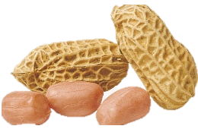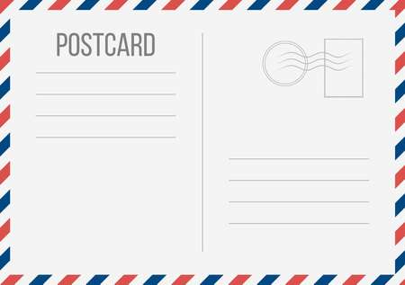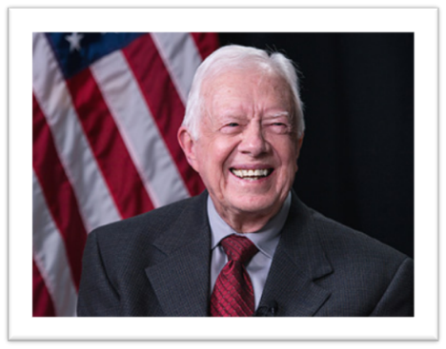

**Please complete the following information and mail along with your student entries to:**

**Marle Usry 300 N. Bond Street Plains, Georgia 31780**

**Number of students participating_____________**

**Grade Level______________**

**Teacher’s name____________________**

**Teacher’s email____________________________________________________**

**School Address________________________________________________________________**

**School Phone #____________________________________ Fax #______________________________**

***Teachers of the winning entries will be contacted by September 10, 2018.***

**Presidents Eat Peanuts!**

**What’s Your Peanut Superpower?**

**Contest Submission Rules**

***Contest is Open to Public, Private, and Homeschooled K-12 Students***

1. All work must be on a white 3x5 unruled index card.

2. The artwork must be original. No copywrite trademarks or images will be accepted.

3. The artwork and message must include peanuts and relate to the theme:

President’s Eat Peanuts!

“What’s Your Peanut Super Power? “

4. All entries will be judged on creativity and use of theme. Original student artwork can use crayons, pencils, pens, and markers.

5. **Student’s name, grade level, teacher’s name, and school name must be on the back of each card.**

6. Mail class entries bundled together in one envelope with the form at the bottom filled out completely.

7. All entries must be postmarked by September 3, 2018.

***2018 Plains Peanut Festival Postcard Contest***

**Sponsored by: The American Peanut Shellers Association,** **The Peanut Institute,** **and the Friends of Jimmy Carter NHS,** **in partnership with JCNHS Education Program**